JavaScript Form Validation using a Sample Registration Form
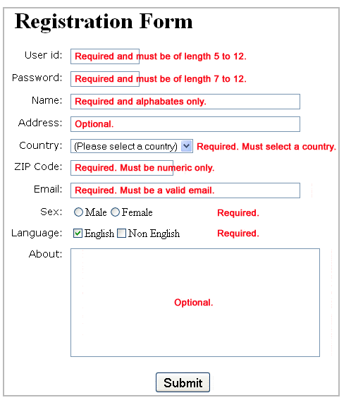
HTML Code of the Sample Registration Form
<!DOCTYPE html>
<html>
<head>
<title>JavaScript Form Validation using a sample registration form
</title>
<link rel='stylesheet' href='js-form-validation.css' type='text/css' />
<script src="sample-registration-form-validation.js"></script>
</head>
<body onload="document.registration.userid.focus();">
<h1>Registration Form</h1>
Use tab keys to move from one input field to the next.
<form name='registration' onSubmit="return formValidation();">
<ul>
<li><label for="userid">User id:</label></li>
<li><input type="text" name="userid" size="12" /></li>
<li><label for="passid">Password:</label></li>
<li><input type="password" name="passid" size="12" /></li>
<li><label for="username">Name:</label></li>
<li><input type="text" name="username" size="50" /></li>
<li><label for="address">Address:</label></li>
<li><input type="text" name="address" size="50" /></li>
<li><label for="country">Country:</label></li>
<li><select name="country">
<option selected="" value="Default">(Please select a country)</option>
<option value="AF">Australia</option>
<option value="AL">Canada</option>
<option value="DZ">India</option>
<option value="AS">Russia</option>
<option value="AD">USA</option>
</select></li>
<li><label for="zip">ZIP Code:</label></li>
<li><input type="text" name="zip" /></li>
<li><label for="email">Email:</label></li>
<li><input type="text" name="email" size="50" /></li>
<li><label id="gender">Sex:</label></li>
<li><input type="radio" name="msex" value="Male" /><span>Male</span></li>
<li><input type="radio" name="fsex" value="Female" /><span>Female</span></li>
<li><label>Language:</label></li>
<li><input type="checkbox" name="en" value="en" checked /><span>English</span></li>
<li><input type="checkbox" name="nonen" value="noen" /><span>Non English</span></li>
<li><label for="desc">About:</label></li>
<li><textarea name="desc" id="desc"></textarea></li>
<li><input type="submit" name="submit" value="Submit" /></li>
</ul>
</form>
</body>
</html>
CSS Code of the Sample Registration Form:
h1
{
margin-left: 70px;
}
form li
{
list-style: none;
margin-bottom: 5px;
}

form ul li label
{
float: left;
clear: left;
width: 100px;
text-align: right;
margin-right: 10px;
font-family:Verdana, Arial, Helvetica, sans-serif;
font-size:14px;
}

form ul li input, select, span
{
float: left;
margin-bottom: 10px;
}

form textarea
{
float: left;
width: 350px;
height: 150px;
}

[type="submit"]
{
clear: left;
margin: 20px 0 0 230px;
font-size:18px
}

p
{
margin-left: 70px;
font-weight: bold;
}
JavaScript code for validation
JavaScript function which is called on onSubmit
function formValidation()
{
var uid = document.registration.userid;
var passid = document.registration.passid;
var uname = document.registration.username;
var uadd = document.registration.address;
var ucountry = document.registration.country;
var uzip = document.registration.zip;
var uemail = document.registration.email;
var umsex = document.registration.msex;
var ufsex = document.registration.fsex; if(userid_validation(uid,5,12))
{
if(passid_validation(passid,7,12))
{
if(allLetter(uname))
{
if(alphanumeric(uadd))
{
if(countryselect(ucountry))
{
if(allnumeric(uzip))
{
if(ValidateEmail(uemail))
{
if(validsex(umsex,ufsex))
{
}
}
}
}
}
}
}
}
return false;
}
JavaScript function for validating userid
function userid_validation(uid,mx,my)
{
var uid_len = uid.value.length;
if (uid_len == 0 || uid_len >= my || uid_len < mx)
{
alert("User Id should not be empty / length be between "+mx+" to "+my);
uid.focus();
return false;
}
return true;
}
JavaScript function for validating password
function passid_validation(passid,mx,my)
{
var passid_len = passid.value.length;
if (passid_len == 0 ||passid_len >= my || passid_len < mx)
{
alert("Password should not be empty / length be between "+mx+" to "+my);
passid.focus();
return false;
}
return true;
}
JavaScript code for validating user name
function allLetter(uname)
{
var letters = /^[A-Za-z]+$/;
if(uname.value.match(letters))
{
return true;
}
else
{
alert('Username must have alphabet characters only');
uname.focus();
return false;
}
}
JavaScript code for validating user address
function alphanumeric(uadd)
{
var letters = /^[0-9a-zA-Z]+$/;
if(uadd.value.match(letters))
{
return true;
}
else
{
alert('User address must have alphanumeric characters only');
uadd.focus();
return false;
}
}
JavaScript code for validating country
function countryselect(ucountry)
{
if(ucountry.value == "Default")
{
alert('Select your country from the list');
ucountry.focus();
return false;
}
else
{
return true;
}
}

JavaScript code for validating ZIP code
function allnumeric(uzip)
{
var numbers = /^[0-9]+$/;
if(uzip.value.match(numbers))
{
return true;
}
else
{
alert('ZIP code must have numeric characters only');
uzip.focus();
return false;
}
}
JavaScript code for validating email format
function ValidateEmail(uemail)
{
var mailformat = /^\w+([\.-]?\w+)*@\w+([\.-]?\w+)*(\.\w{2,3})+$/;
if(uemail.value.match(mailformat))
{
return true;
}
else
{
alert("You have entered an invalid email address!");
uemail.focus();
return false;
}
}
JavaScript code for validating gender
function validsex(umsex,ufsex)
{
x=0;

if(umsex.checked)
{
x++;
}
if(ufsex.checked)
{
x++;
}
if(x==0)
{
alert('Select Male/Female');
umsex.focus();
return false;
}
else
{
alert('Form Successfully Submitted');
window.location.reload()
return true;
}

}
Phone Number Validation
function phonenumber(inputtxt)
{
var phoneno = /^\d{10}$/;
if((inputtxt.value.match(phoneno))
{
return true;
}
else
{
alert("message");
return false;
}
}

